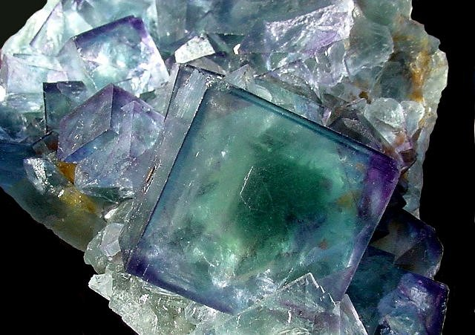
Fascinated by fluorite?

Got a thing for galena?

Losing it for leucite?
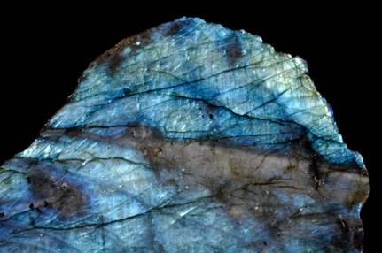
Mad about malachite?
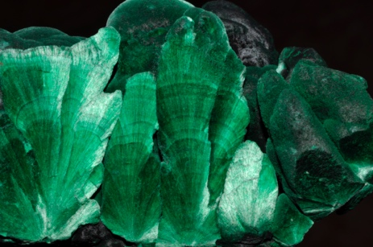
Taken by tectosilicates?

Enthused by epidote?
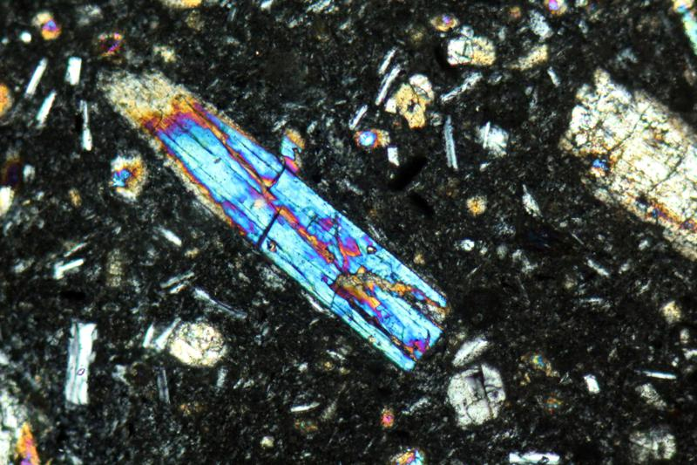

Dreaming of diopside?

…then MINERALS are for YOU! Help us crown the year’s best!

Join our inaugural Macalester Mineral Cup, hosted by the Mineralogy class of 2023!

3-minute mineral presentations April 12, 13, 14 @ 1:15 pm!
voting is bracket-style, beginning April 12

Mineral Cup Project

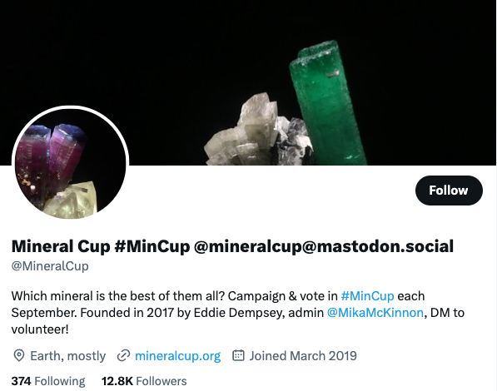
Each year, Twitter holds a “Mineral Cup” with a bracket and polls to determine the year’s best mineral. Geoscientists and the public alike get very into this, championing their chosen minerals with posts about their utility, beauty, physical properties, historical significance, and other interesting information. We will hold our own departmental Mineral Cup after spring break!

Overview
Research your chosen mineral, synthesize your work in a written document, and present your mineral to the class, convincing us that it should be crowned this year’s MacMin Champion.

Details
[1] Mineral Basics Sheet. Accurately fill out the mineral information template I’ve given you. Note there are seven images required. For the final prompt (how to ID in hand sample and thin section), answer in two well-written paragraphs. I am not asking you to regurgitate a list of non-specific mineral properties; I am asking you to think critically and describe the properties and methods that are most likely to help someone identify your specific mineral. What property is most diagnostic? Is it easy to measure? If not, what methods are more accessible that might still help you ID the mineral? These are the sorts of questions to think about. You don’t need to specifically answer these, but they should help guide you.

[2] Mineral Research. Find three scientific journal articles that are focused on your mineral and of interest you. They don’t have to be related, although you might have an easier time if the topics are similar. Write a brief synthesis of what you have learned and where you think the science could lead / what future directions of research could be fruitful. You should format this as a five-paragraph writeup. Paragraph 1 should introduce your mineral with some relevant basic properties and a quick intro to the research work you will summarize in the next paragraphs. Paragraphs 2–4 should each summarize one of the three papers you read. Use your own words. Connect the paragraphs; even if the topics are unrelated, you can find a transition sentence that helps with the logical flow. Paragraph 5 should wrap up and briefly discuss some potential future avenues of research that you think would be interesting and worth pursuing, for this mineral. Write the final paragraph persuasively, as if you were asking for research funding! At the end, include a bibliography (works cited). It will likely consist of only the three articles, and that is fine. Use the reference format I give you in the template.

[3] Lightning Talk. You will prepare a 3-minute talk about your mineral, which you will present to the class. The purpose of this talk is to impart some basic information about your mineral to the group, and then to convince us that it’s the best mineral and everyone should vote for it in our bracket. Your presentation should be in the form of a powerpoint. You may include as many slides as you would like, but you will have a strict 3-minute time limit, so be judicious when choosing what to include. Some people would suggest 3 slides in 3 minutes, but sometimes I prefer to have a single large image on a slide, or to have multiple slides in lieu of animating text pop-ups. So, the slide count is up to you as long as you stay within the time limit. Your presentation should be largely given at a level that a non-specialist could understand (e.g., last-semester you!). Please include: (1) some brief mineral basics (e.g., “Quartz is a tectosilicate mineral in the hexagonal system, with the formula SiO₂; it is one of the last minerals to form from most igneous melts, but its resistance to weathering makes it common on Earth’s surface. Chemical impurities impart a variety of colors to this otherwise clear mineral.”), (2) at least one historical factoid about the mineral (e.g., how it has traditionally been used, how it got its name, famous people who have some connection to it, etc.), and (3) at least one piece of information about how the mineral is used in the world today (e.g., in building materials, as jewelry, in technology, etc.). The presentation also needs to include at least three different images of the mineral. Within and beyond these simple requirements, you can talk about whatever is interesting / beautiful / bonkers about your mineral. Make us love it!

We will invite the department to see your talks and vote on the mineral bracket, to share our cool minerals with a larger audience. The winner gets the glory, but it won’t affect your grade!

Format
Submit [1] and [2] as a single word document in Moodle. Just follow the format I’ve given you. Submit your presentation for [3] as a pptx file in Moodle.

Timeline
March 8 Submit PDFs of the three articles you have chosen (counts as a HW)
March 22 24 Submit a draft of [2] (counts as a HW)
April 5 10 Document [1]–[2] due
April 12, 13, 14 Lightning Presentations (6 per day; pptx [3] due the day you present)

Evaluation
Each section will be evaluated on a 1–5 scale. Your grade will be assigned according to:
Points | 14–15 | 12–13 | 10–11 | 8–9 | 6–7 | 5 | 4 | 3 | 2 | 1
Letter | A | A- | B+ | B | B- | C+ | C | C- | D | F

[1] Mineral Basics Sheet
1 | 2 | 3 | 4 | 5
Many inaccuracies and/or missing elements, ID paragraphs non-specific or illogical | Some inaccuracies and/or missing elements, ID paragraphs lack some specificity or logic | Complete and mostly accurate, ID paragraphs are mineral-specific but do not demonstrate synthesis of properties and methods | Complete with minor inaccuracy, ID paragraphs are mineral-specific and demonstrate fair to good synthesis of relevant methods, properties | Complete and accurate, ID paragraphs are mineral-specific and demonstrate excellent synthesis of relevant properties and methods

[2] Mineral Research
1 | 2 | 3 | 4 | 5
Summaries unclear and/or inaccurate, no logical flow, fundamental misunderstanding of material, future directions absent or illogical | Summaries mostly unclear or inaccurate, little logical flow, tenuous grasp of material, many inaccuracies, future directions lack logic | Mixed clarity and accuracy of summaries, logical flow for most parts, fair grasp of material, mostly accurate, future directions very basic | Mostly clear summaries, logical flow, good grasp of material, mostly accurate, good future directions | Clear and concise summaries, logical flow, excellent grasp of material, accurate, thoughtful and reasoned future directions

[3] Lightning Talk
1 | 2 | 3 | 4 | 5
Slides busy/messy or illegible, missing most required info, lack of engagement with audience, logical flow absent, time limit issues | Many slides busy/messy or illegible, missing some required info, lack of engagement with audience, logical flow minimal, time limit issues | Mixed slide legibility and neatness, most required info given, some engagement, issues with logical flow and/or time limit | Most slides neat and legible, all required info given, presentation is mostly engaging and persuasive, logical, time limit respected | All slides neat and legible, all required info given, presentation is engaging, logical, persuasive, time limit respected

