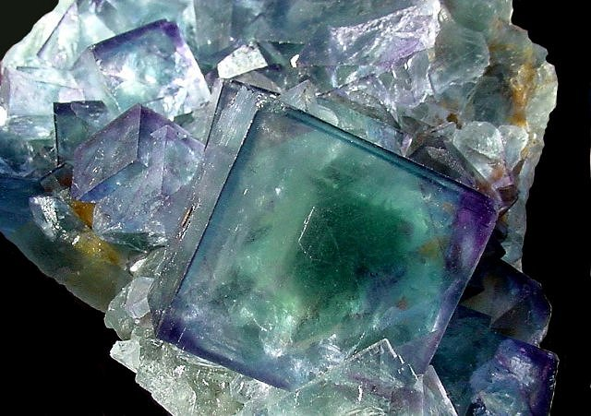
Fascinated by fluorite?

Got a thing for galena?

Losing it for leucite?
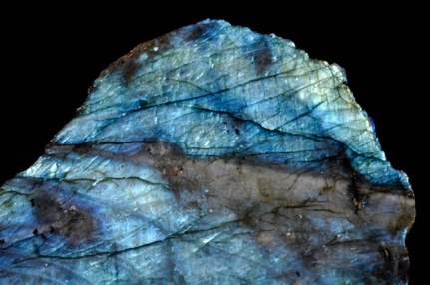
Mad about malachite?
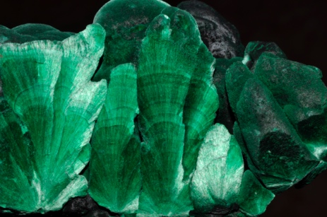
Taken by tectosilicates?

Enthused by epidote?
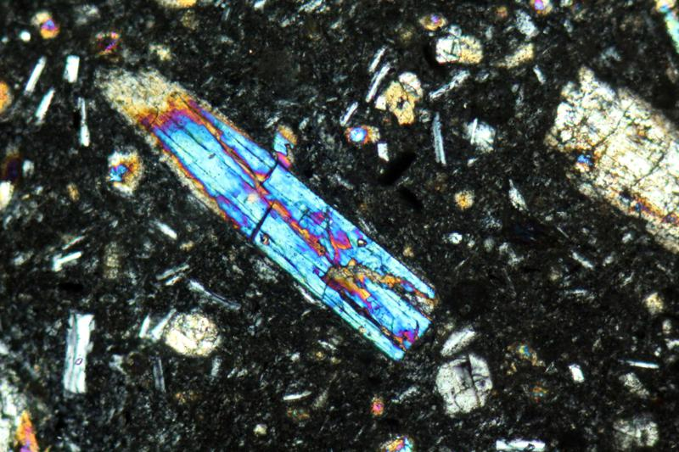

Dreaming of diopside?

…then MINERALS are for YOU! Help us crown the year’s best!

Join our inaugural Macalester Mineral Cup, hosted by the Mineralogy class of 2023!

3-minute mineral presentations April 12, 13, 14 @ 1:15 pm!
voting is bracket-style, beginning April 12

